* + - **Example Product**: E-Commerce Website

**Task 13 :- waterfall model**

* + **Requirement Gathering & Analysis**
  + **System Design**
  + **Implementation**
  + **Testing**
  + **Deployment**
  + **Maint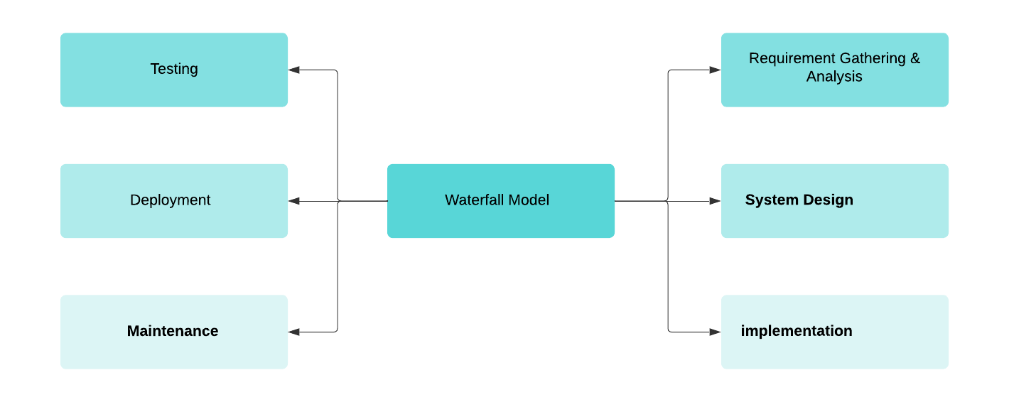enance**

1. **Requirement Gathering & Analysis**:
   * Identify business goals and target audience.
   * Create user personas (e.g., Shoppers, Admins).
   * Define product catalog, user registration, payment methods, and order tracking.
   * Finalize Requirements Document.
2. **System Design**:
   1. Design website architecture (frontend, backend, database).
   2. Create wireframes for the user interface (home page, product page, checkout).
   3. Design API for payment integration.
   4. Choose technologies: React for frontend, Node.js for backend, MongoDB for database.
3. **Implementation**:
   1. Code the frontend with user registration, product listings, and search functionality.
   2. Backend setup for inventory management, payment processing, and order history.
   3. Connect frontend and backend via API.
   4. Set up database for product storage and customer information.
4. **Testing**:
   1. Perform unit tests on product listings, cart functionality, and payment system.
   2. Integration testing for smooth interactions between frontend, backend, and payment gateways.
   3. Conduct usability tests to ensure user-friendly navigation.
   4. Fix identified bugs.
5. **Deployment**:
   1. Deploy the website on a cloud server (AWS, Google Cloud, etc.).
   2. Set up DNS, SSL certificates, and performance monitoring tools.
   3. Perform final checks for security and performance.
6. **Maintenance**:
   1. Provide support for bugs and user-reported issues.
   2. Implement periodic updates, security patches, and performance improvements.
   3. Add new features like wish lists or product recommendations based on user feedback.

TEAMLEOS35

* D.VISHALI
* RENU
* M.HANSIKA REDDY
* B.LOKESH
* G.HIMASAGAR REDDY
* D.DHEERAJ

THANKYOU